Grade 7 Accelerated · Unit 3 · Lesson 8  Writing Large Numbers in Scientific Notation  Question Bank 3.08 | Name______________________  Date______________________  Period____________________

Show your work. Circle your final answer.
For questions 1 through 4, write each number in scientific notation.
1. 9,000

2. 4,500,000

3. 310,000,000

4. 7,020,000,000

For questions 5 and 6, write each number in standard form.
5. 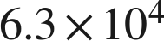

6. 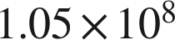

Real quantities.
7. Write each quantity in scientific notation.
a. There are about 1,670,000,000,000,000,000,000 molecules in a drop of water.

b. The average distance from Earth to the Sun is about 93,000,000 miles.

c. A computer displays the number of stars in a galaxy as 4E11. Write it in standard form.

8. Complete each comparison.
a. How many times larger is 8.1 than 5.4?

b. How many times larger is  than ?

c. How many times larger is 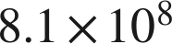 than 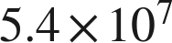?

9. Answer each question.
a. A blue whale weighs about 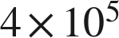 pounds. An elephant weighs about  pounds. How many times heavier is the blue whale?

b. Florida has an area of about 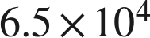 square miles. Lake Okeechobee has an area of about 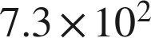 square miles. About how many times larger is Florida? Round to the nearest whole number.

10. Which of the following is greater? Explain how you know.
a. 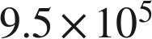 or 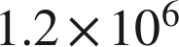

b. 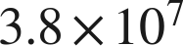 or 

11. Which is 52,000,000 written in scientific notation?
○ A. 
○ B. 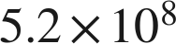
○ C. 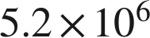
○ D. 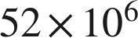

12. Select ALL of the expressions that are equal in value to 3,400,000.
□ A. 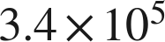
□ B. 
□ C. 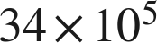
□ D. 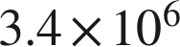
□ E. 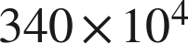
□ F. 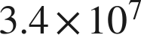

13. In question 12, only one of the four equal expressions is written in scientific notation. Which one is it, and why are the other three not?

